Build tool:

* Build tools automate the process of packaging a software, packaging a software involves lot of steps.

1. Create deployment folder structure
2. Then get all dependencies used by developers in the code
3. Compile source code. (if dependencies 0000000 compiling fails)
4. Move appropriate files onto appropriate locations.
5. Create a package (jar/war/ear) – this is for java projects

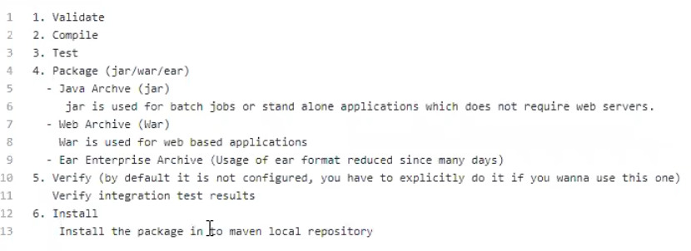

Refer this link <https://github.com/javahomehari/devops-we-aug-2019>

* JAR : java archive – this format is used for stand-alone projects – which is not a web based app called as stand-alone project.
* WAR: web archive
* EAR: Enterprise Archive (not used much now a days)
* Once we get jar/war/ear ready to deploy – ready to run

There are diff build tools in the market

1. For java
2. Maven
3. Ant
4. Gradle
5. Dotnet
6. Ms Build
7. Android
8. Gradle
9. C/C++
10. Make

**Apache Maven**

* It is open source written in java
* written in java
* majority of java projects use maven today
* we see how to install maven on windows after we see it in Linux

**Install maven on windows:**

1. Install JDK8 and set path to Java (optional)
2. Add bin to the path, (C:\Program Files\Java\jdk1.8.0_231\bin)
3. Download maven

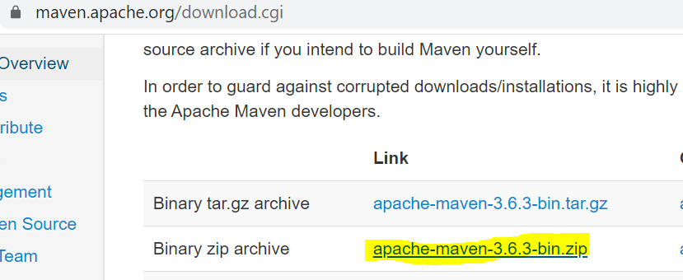

Unzip that

* Add maven build folder to the path environment variables.
* Add JAVA_HOME environment variables and point in to JDK installation.
* To check these are correctly installed or not – go to cmd and then check javac and mvn -v

**Ex1:**

Clone java project from Git and build that project using Maven

<https://github.com/javahometech/myweb> - this is maven based java project.

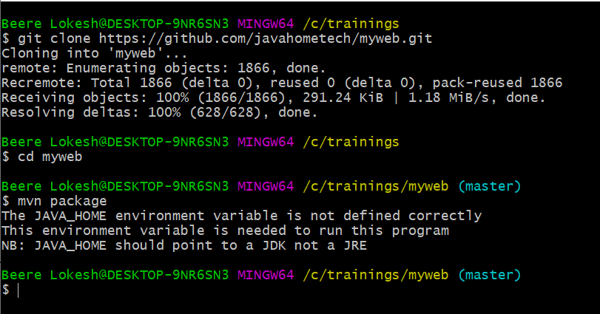

**Maven dependencies:**

Maven downloads dependencies automatically using that details configured in pom.xml, this file is generated by developpers and dependencies added by developper.

It downlaods that jar file maven reposi

IQ) What are Maven repositories.

Maven repository is a server where we can locate JAR/WAR/EAR

Maven uses 3 diff repositories

1. Cental repository – It’s a server exposed to internet – we can find all open source JAR files in central repository.

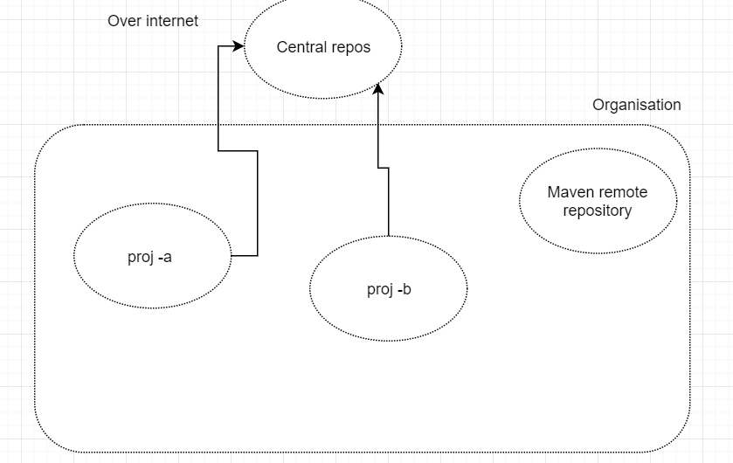

1. Remote repository­ – It is like central but it’s scope is like our company N/w , servers In our company can use it.

Note: we need to update setting.xml of maven in order to configure remote repository details

We can use sonar type Nexus or j-frog artifactory as a remote repository

Maven can be configured to interact with remote and central repository

Local repo:

It is a local machine when you run your Maven cmds.

IQ) Diff b/w Git repo and maven repository

1. Git repo contains source code , maven repo contains packages

IQ) what is default maven local repository path?

1. User_Home \.m2\repository

25-12-19

Q) What is Maven build life cycle (v.imp)

**1. Validate** – It validates pom.xml

* It checks+ syntaxes
* Checks validness of file i.e we can’t put our own tags
* Dependencies of file

**2.It goes and compiles the code**

3.**Test** ( Run J unit test cases) – Executes unit test cases.

j unit is unit testing frame work

Developpers write logic as well as they write J unit test cases.

**4.It creates Deployable package .**

- Jar /war/ear - developpers choose this.

**5.verify:**

- This feature is by default disabled.

This feature can be used to verify integration test results.like selenium , Qtp etc

**6.Install:**

- copies a package to local repository.

**7.Deploy:**

Deploy uploads your package to remote repository.

**Example:**

We have 2 projects one.jar and two.war

Two.war depends on one.jar

Lets create 2 maven projects

(mvn archetype:generate -DgroupId=In.Javahome -DartifactId=one -DarchetypeArtifactId=maven-archetype-web -DinteractiveMode=false)

Generally, Group id is company name

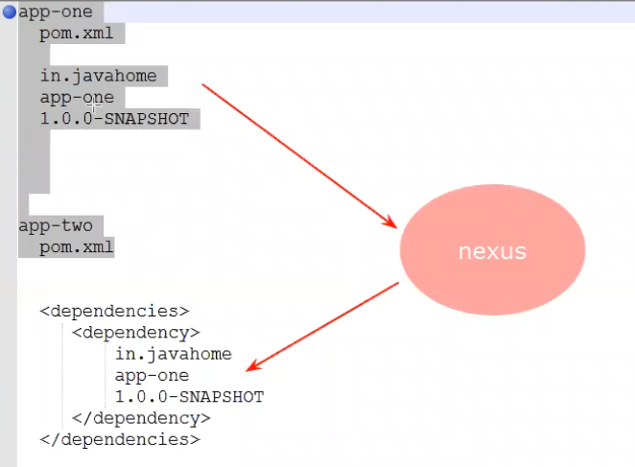

Pom.xml:

It is configuration file used by maven; this file will be in project root without pom file maven fails.

It is mandatory

Details of pom.xml:

Group ID: reverse domain name of the client ex: in.javahome

Artifact ID : it is project name

Version: current project version.

Packaging: package name Default is Jar.

Dependencies:

Plugins: we can extend maven functionality by adding Plugins.

For generating j-unit

**WHAT IS SNAPSHOT and RELEASE versions in maven (IQ)**

How to skip test phase in maven build life cycle.

* mvn package -Dskiptests=True

(or)

* mvn package -Dmaven.test.skip=true

it shows tests are skipped

can we change default local repository location :

yes , mostly we wont do

we have to do this in (mavensettings.xml)

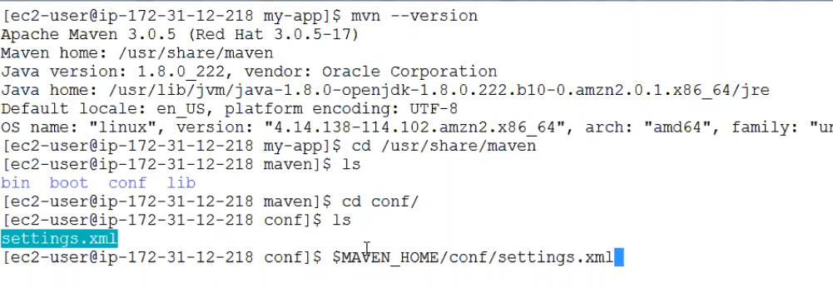

Vi setting.xml

Deploy web applications:

1. we need web servers to run web apps.
2. There are several web servers in the market

* For java

Apache tomacat

* Oracle web logic
* Sun glass fish
* Ibm web sphere
* jboss
* pranathi app server etc.

(tomcat is mostly commonly used)

For .net we have only one

IIS

PHP:

* we use apache server
* apache tomcat
* Nginix – can be used as a web server or load balancer

We use light weight web server for deploying java web apps.

It is open source, it is written in java,

Download and install tomcat on windows., tomcat requires java as a dependency.

Go to tomcat home/bin

Double click starts up windows patch file, that opens a terminal

Open web browser

We can access tomcat from web server.

Type localhost:8080

26-12-19

**Deploying our web app on tomcat:**

Tomcat has deployment folder web apps, if u want to run web app we must keep it in web apps

C:\apache-tomcat-8.5.50\webapps

Git pull

Mvn package

Package is always kept in targetfolder

**Tomcat logs:**

If there are deployment issues, we trouble shoot using logs

We see 2 types of logs here

**Tomcat logs:**

* C:\apache-tomcat-8.5.50\logs (i.e tomcat_home\logs)

**Application Logs:**

Let’s say Application deployed successfully and a specific functionality is not working we have to refer to application logs.

Developpers will not have access to these servers and files as a devops engineer you have to share those details with dev team.

Developpers will have access to git from git Jenkins will pull that and deploy on to test prod uat dev servers

You devops guy have access to dev ,test ,uat, prod 🡪

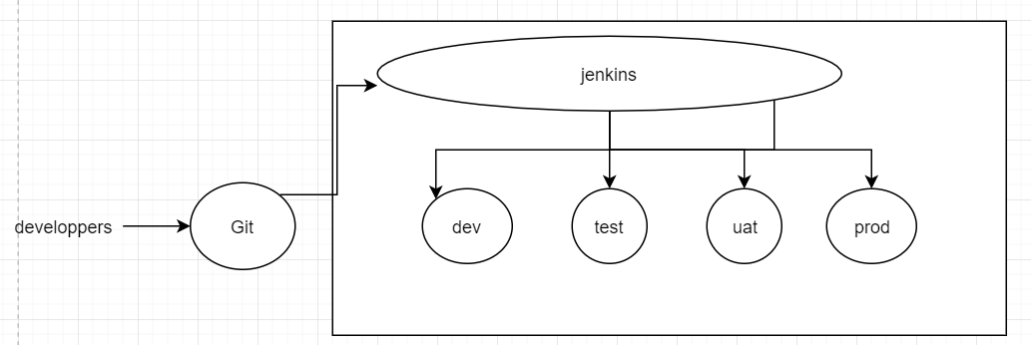

The location of app logs is configured by dev team

Limited people have access to prod.

Every time we have new deployment we need to restart the server

IQ) Can we change port number of tomcat?

Yes, tomcat ,conf\ server.xml

C:\apache-tomcat-8.5.50\conf

**Tomcat manager app :**

* It is web based app for managing applications on tomcat

Ex: we can deploy applications using manager app

* We can undeploy and redeploy a specific application without restarting tomcat server.

By default, it is configured to access only from local host. we also must configure username and password

* Configuring username & password
* C:\apache-tomcat-8.5.50\conf
* 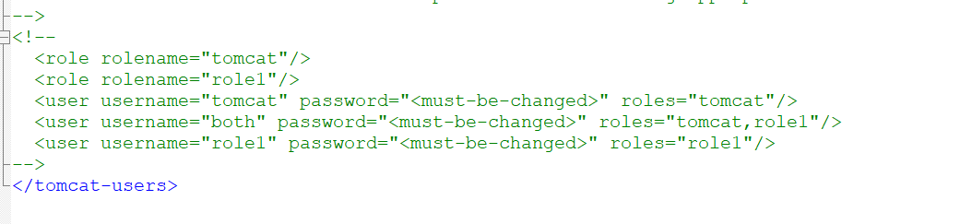

For changing password

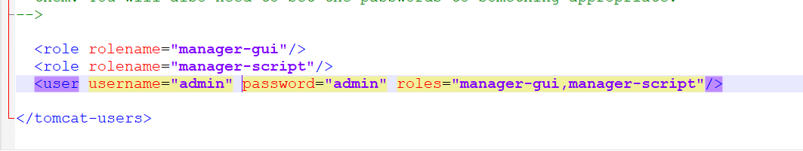

Then run <http://localhost:8080/manager/html> on browser

Given admin password ; admin

IQ) Have you seen out of memory error

When lauch

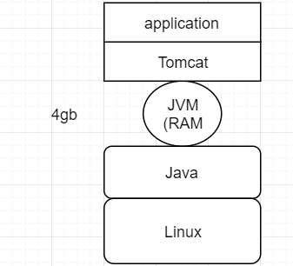

If there is no sufficient Ram allocate to JVM it can run out of memory.

How do you fix out of memory error:

* Temporary fix is increasing heap size and restart the server
* Permanent fix is find the root cause and fix it.

That trouble shoot is called profiling, java guys do that

**MAven SNAPSHOT and RELEASE version**

SNAPSHOT and RELEASE is maven conventions

**RELEASE Version**

According to maven convention dependency with RELEASE version will not have new changes, maven downloads it from central/remote ones and depends on local copy next time onwards. if version is not ending with -SNAPSHOT then it is release

**SNAPSHOT Version**

According to maven convention dependency with SNAPSHOT version will have new changes, maven downloads it from central/remote every time you build your application.

if version is ending with -SNAPSHOT then it is SNAPSHOT